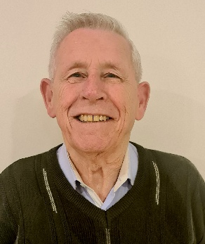
Paul Ward
Spiritual Healer
Trance Healer
Trance Medium
Physical Medium

Paul has been working with Spirit for over 20 years and in the last 6 years has focused on Physical Mediumship. Physical phenomena occurs in his presence.
Paul is still sitting for Physical Mediumship development and looking forward to whatever Spirit bring.

Paul strives to heal the body and the spirit through healing and bring comfort and understanding by sharing the knowledge that life continues after physical death.

